
1. This is the login page, I have designed the logo, if here any inputs please show?
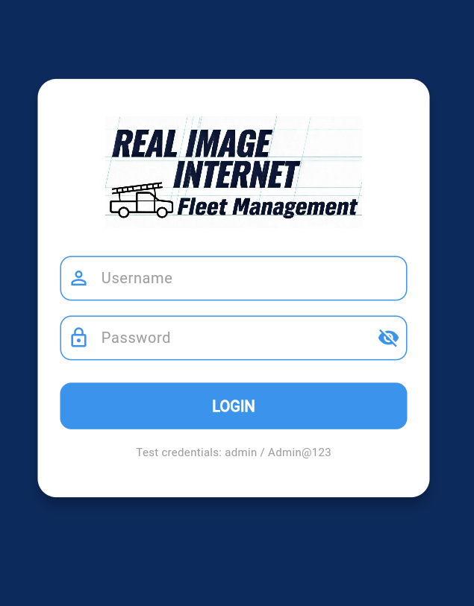
2. This is the dash-board, it shows Jobs available for that day. The logged in user. The dashboard shows statistics for that particular day.
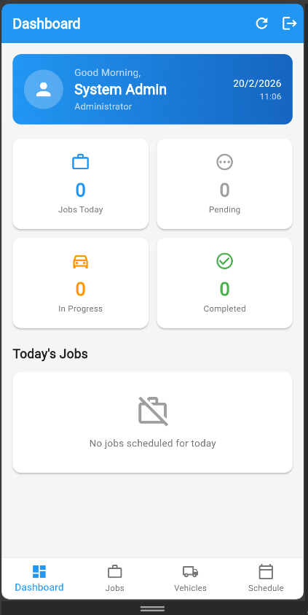
3. The jobs panel show jobs that are pending, assigned, in-progress, completed and cancelled. The new job button opens a form to add a new job and assign vehicles
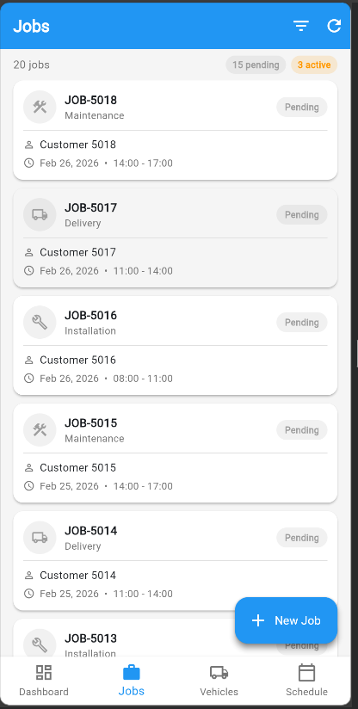
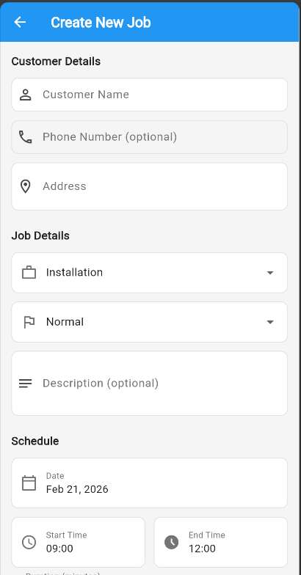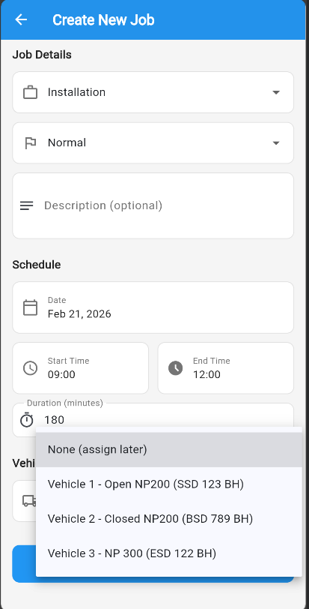

4. The Vehicle panel shows vehicles available I am still to add CRUD features to add, remove, update cars.
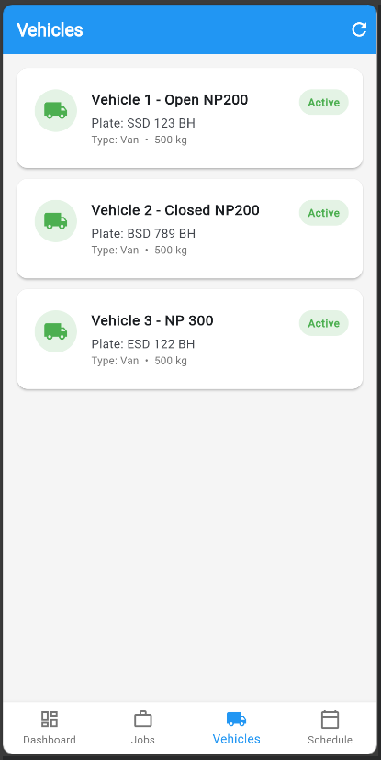
5. Schedule panel visually presents jobs and vehicle assignments by day and by week
